Exercise-1

Question-1.1

Find the title of each film.

Output:-

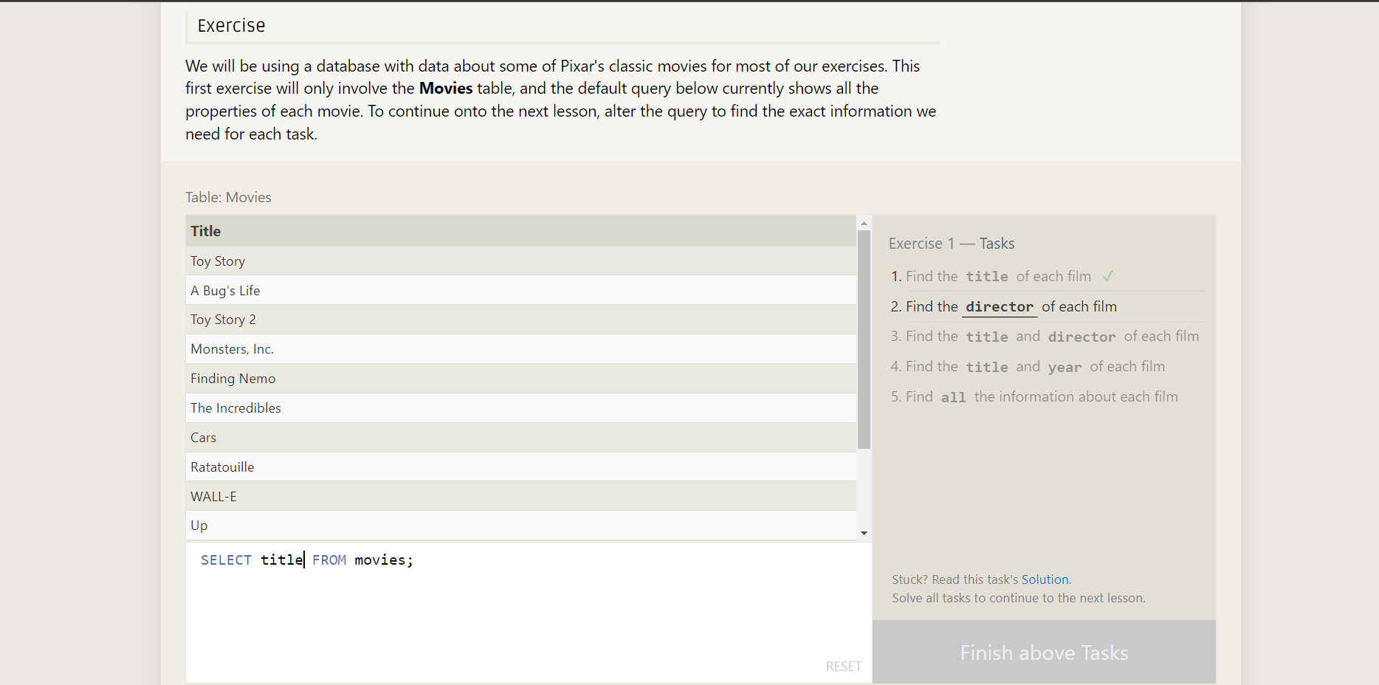

Question-1.2

Find the director of each film.

Output :-

Question-1.3

Find the title and director of each film.

Output:-

Question-1.4

Find the title and year.

Output :-

Question-1.5

Find all information about each movie.

Output:-

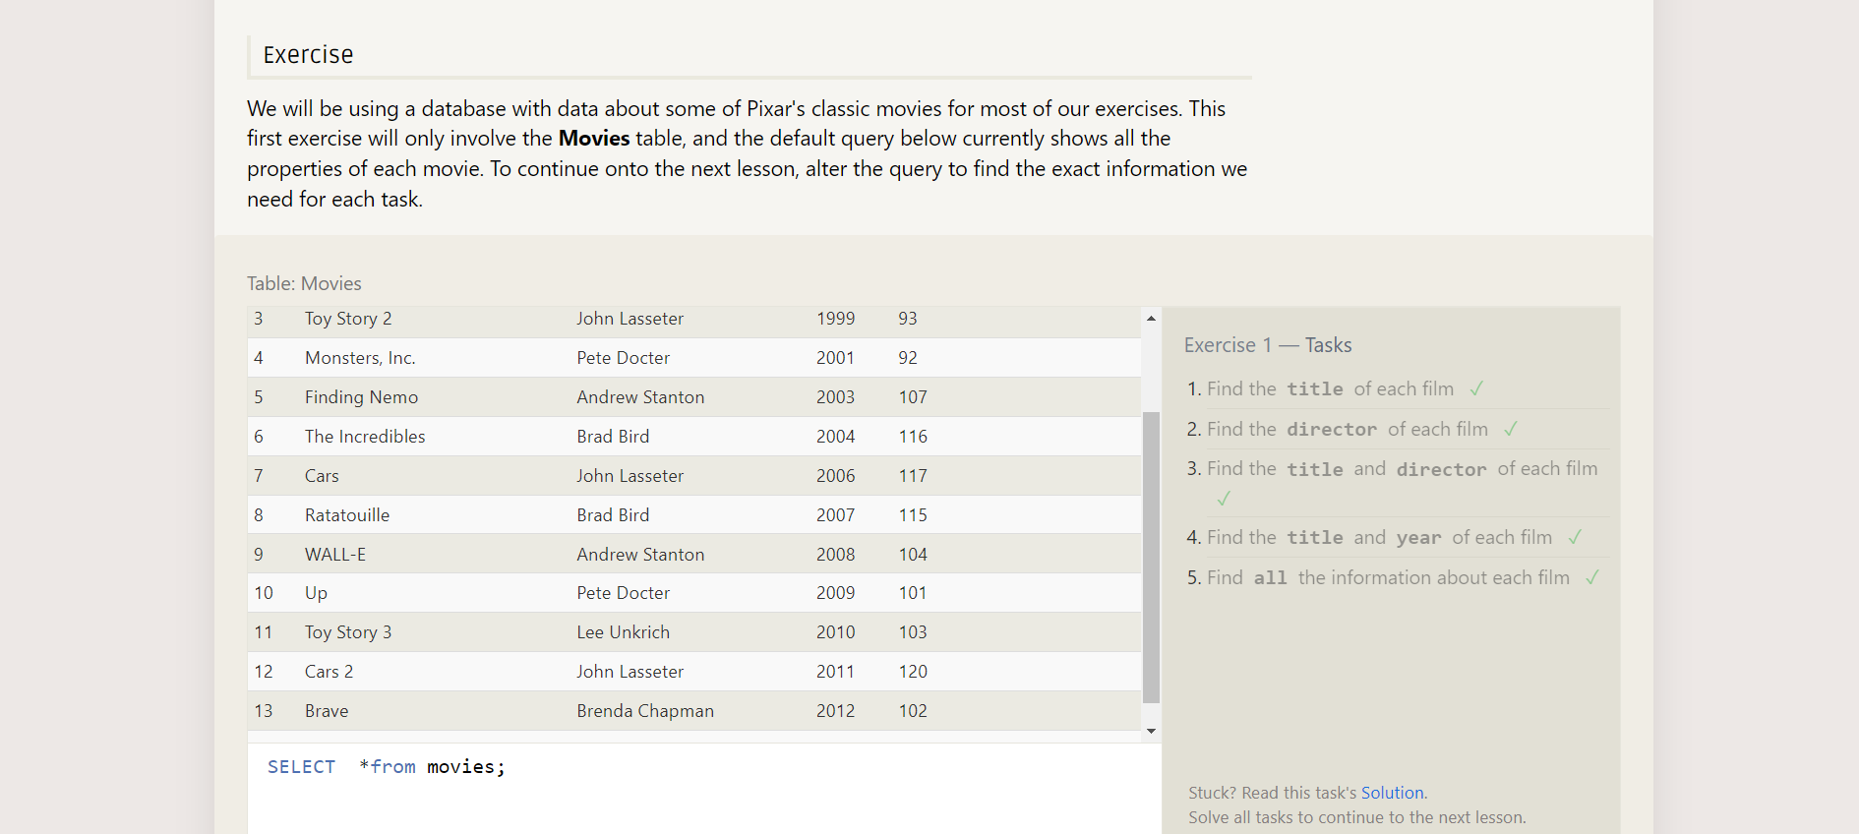

Exercise-2

Question-2.1

Find the movie with id=6.

Output:-

Question-2.2

Find the movie which released between 2000 to 2010.

Output:-

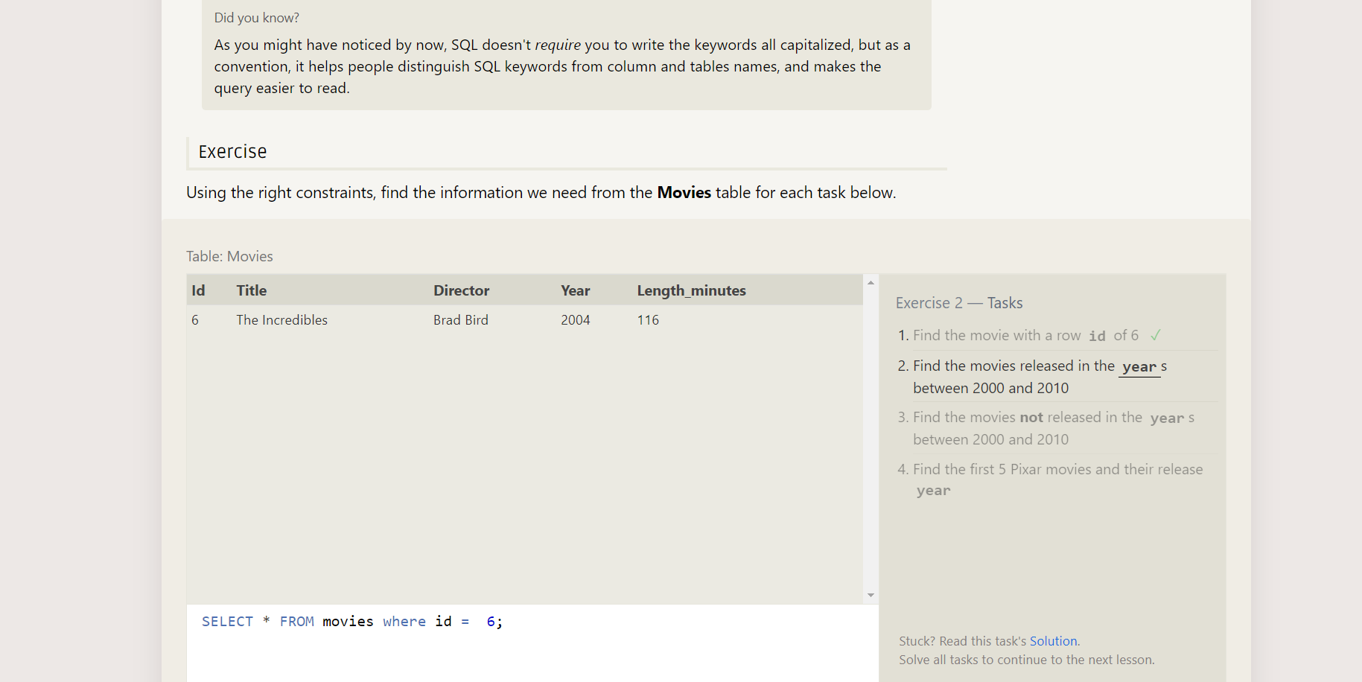

Question-2.2

Find the movie released between 2000 and 2010.

Output:-

Question-2.3

Find the movie which is not between 2000 and 2010.

Output:-

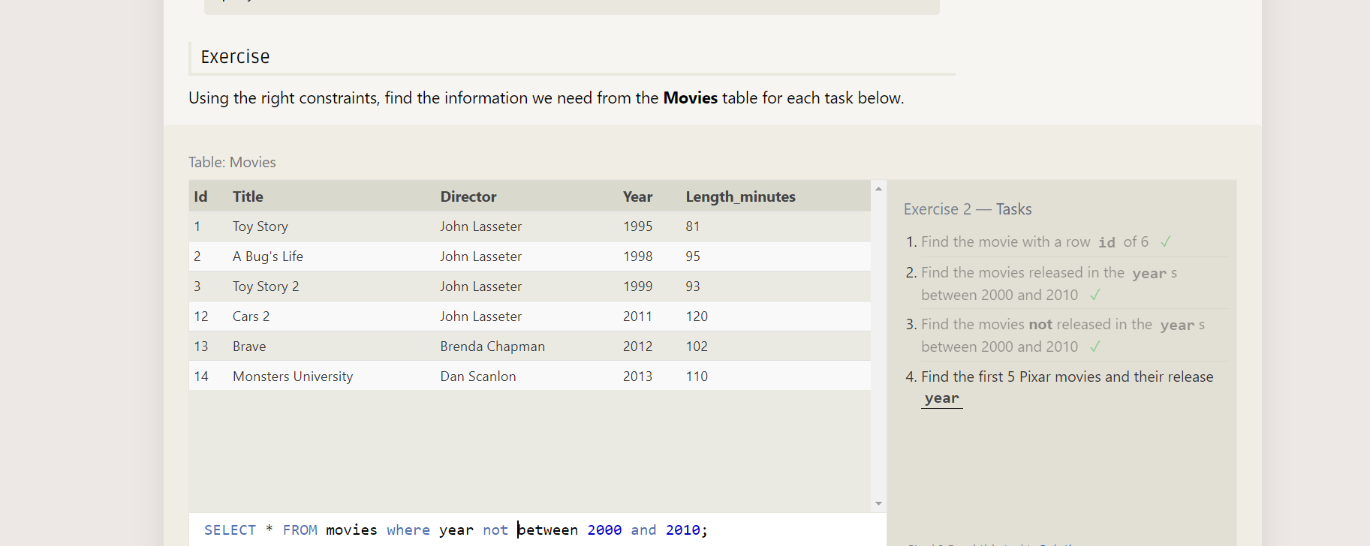

Question-2.4

Find 5 pixer movies and their released year.

Output:-

Exercise-3

Question-3.1Find the all toy story movie.

Output:-

Question-3.2

Find all movies directed by john Lasseter.

Output:-

Question-3.3

Find all movies not directed by john Lasseter.

Output:-

Question-3.4

Find all WALL movie.

Output:-

Exercise-4

Question-4.1

List all director of pixar movies without duplicates.

Output:-

Question-4.2

Last four pixar movies(most recent to last).

Output:-

Question-4.3

List first five pixar movie sorted by alphabeticaly.

Output:-

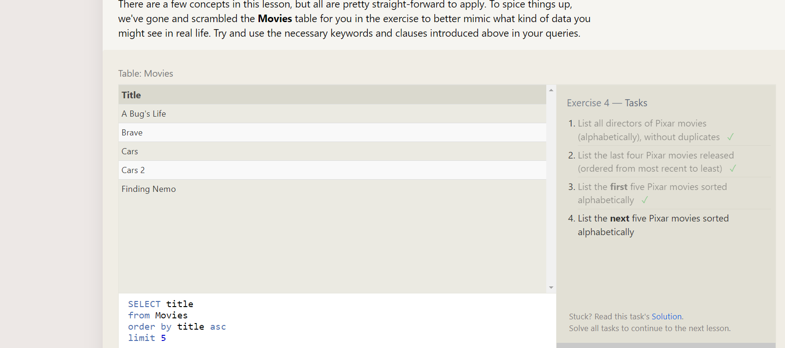

Question-4.4

List next five pixar movie.

Output:-

Exercise-5

Question-5.1

Canadian cities population.

Output:-

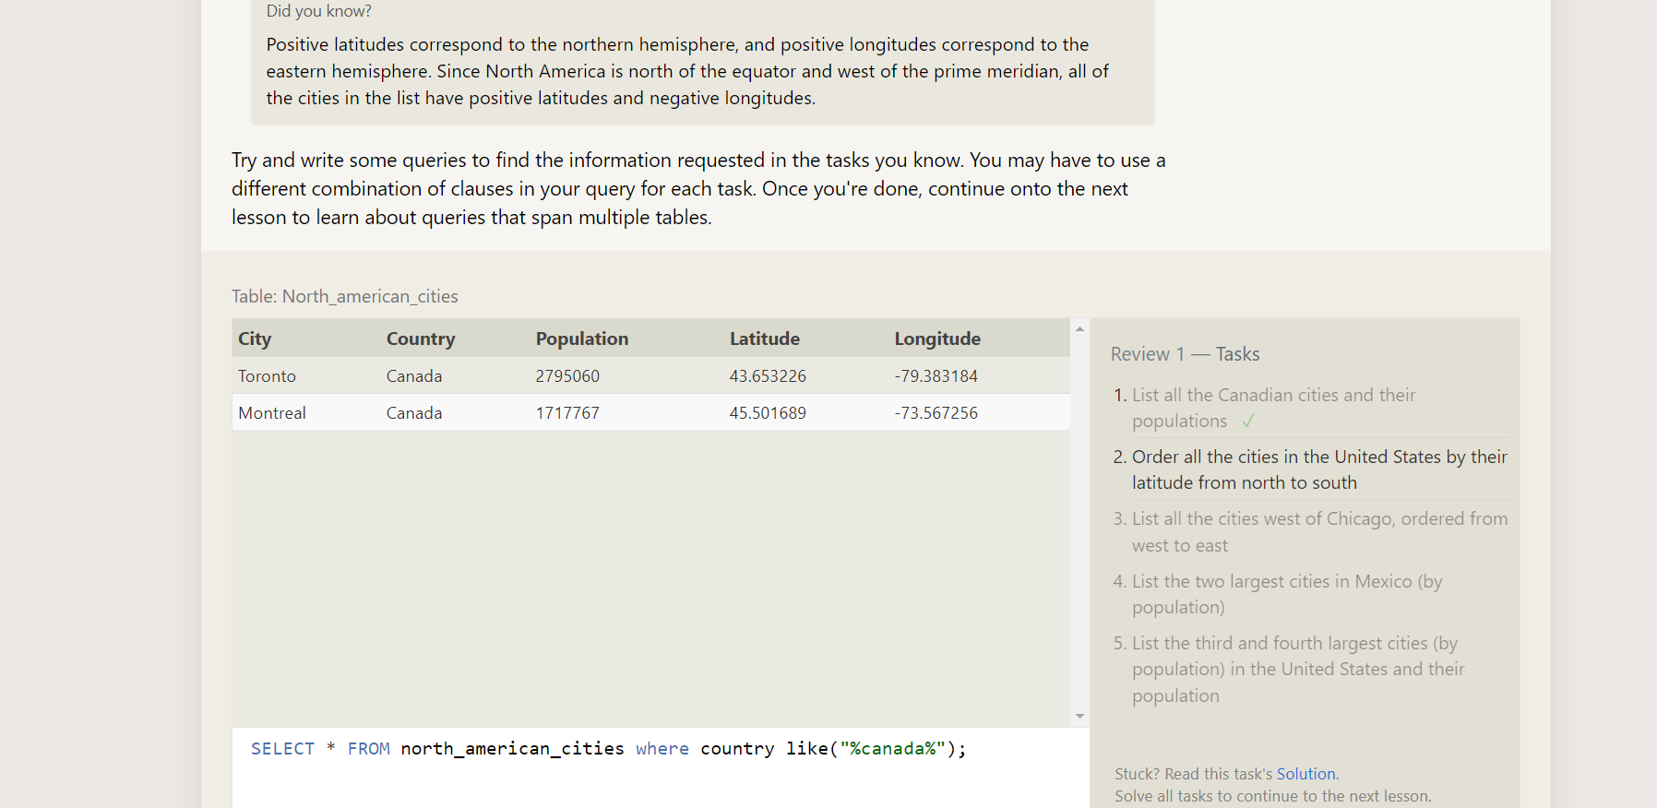

Question-5.2

Order all the cities from their latitude from north south.

Output:-

Question-5.3

List all the cities west of Chicago, ordered from west to east.

Output:-

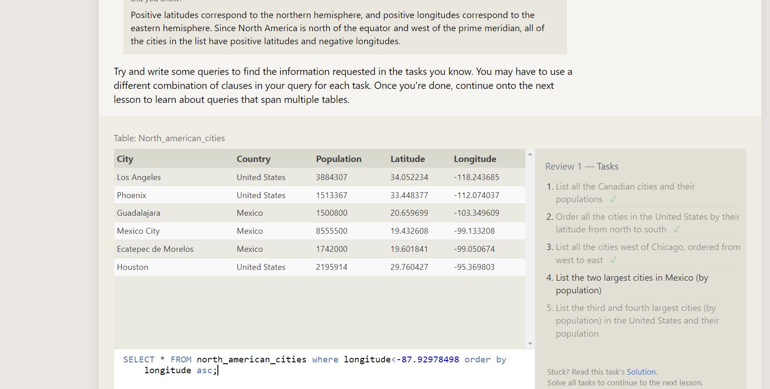

Question-5.4

List of two largest city in (Mexico by population).

Output:-

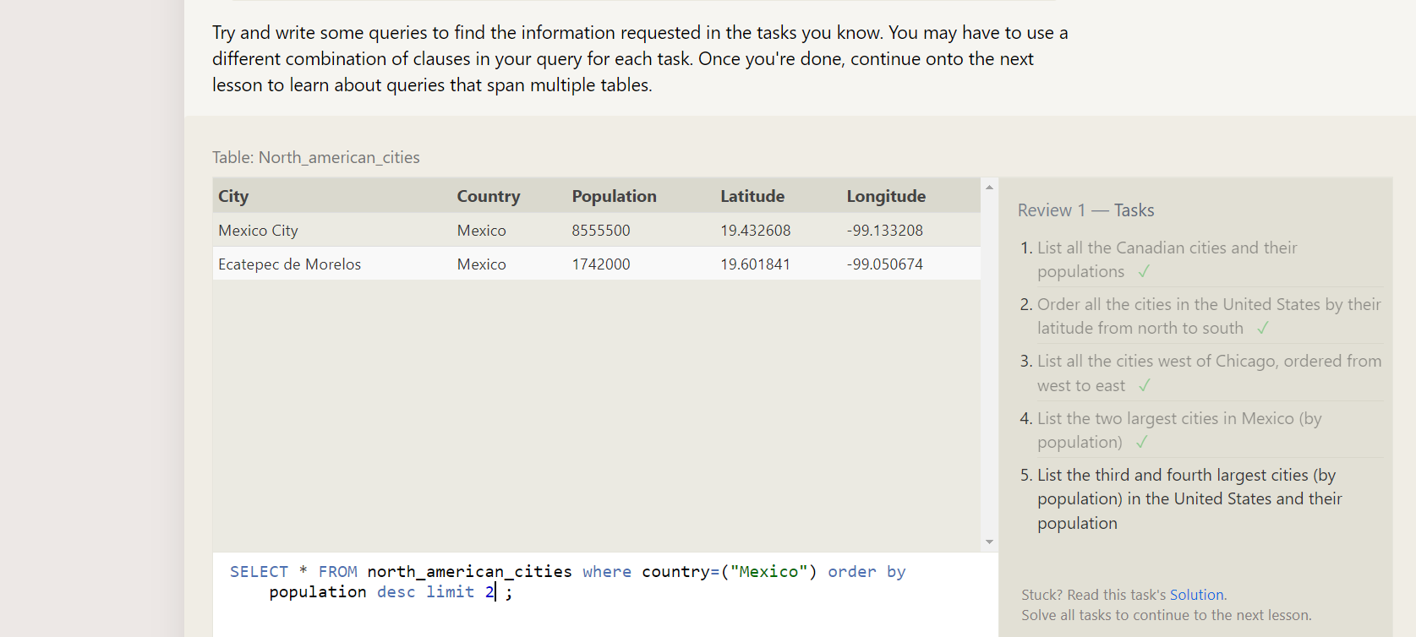

Question-5.5

List 3rd and 4th cities by population in the united states and their population.

Output:-

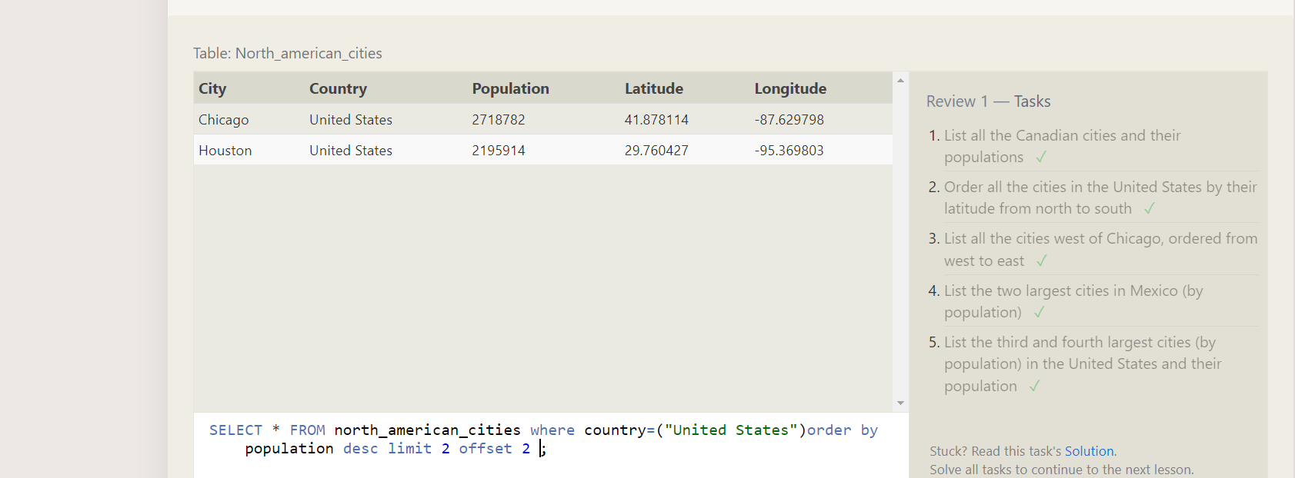

Exercise-6

Question-6.1

Find the domestic and international sales for each movie.

Output:-

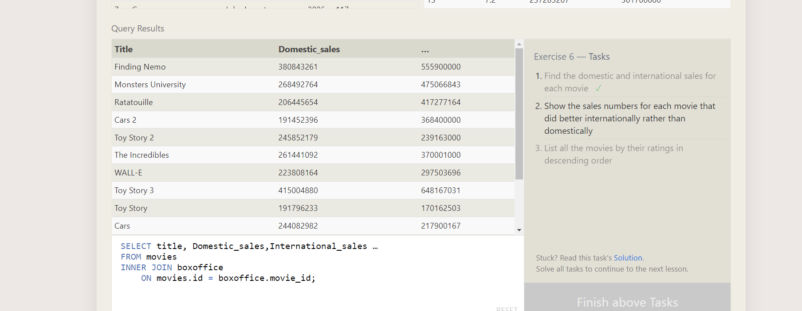

Question-6.2

Show sales for each movie that did better rather than domestically.

Output:-

Question-6.3

List of all movies by their rating in descending order.

Output:-

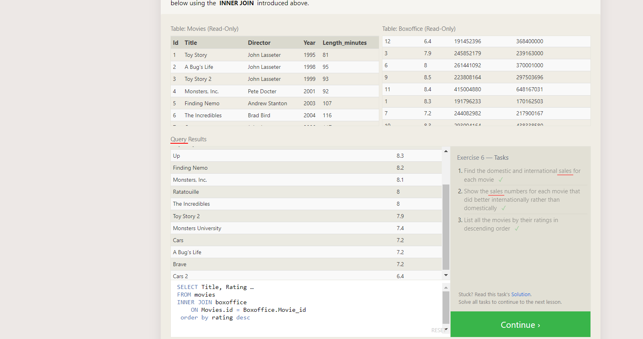

Exercise-7

Question-7.1mployees

Find the list of building that have employees.

Output:-

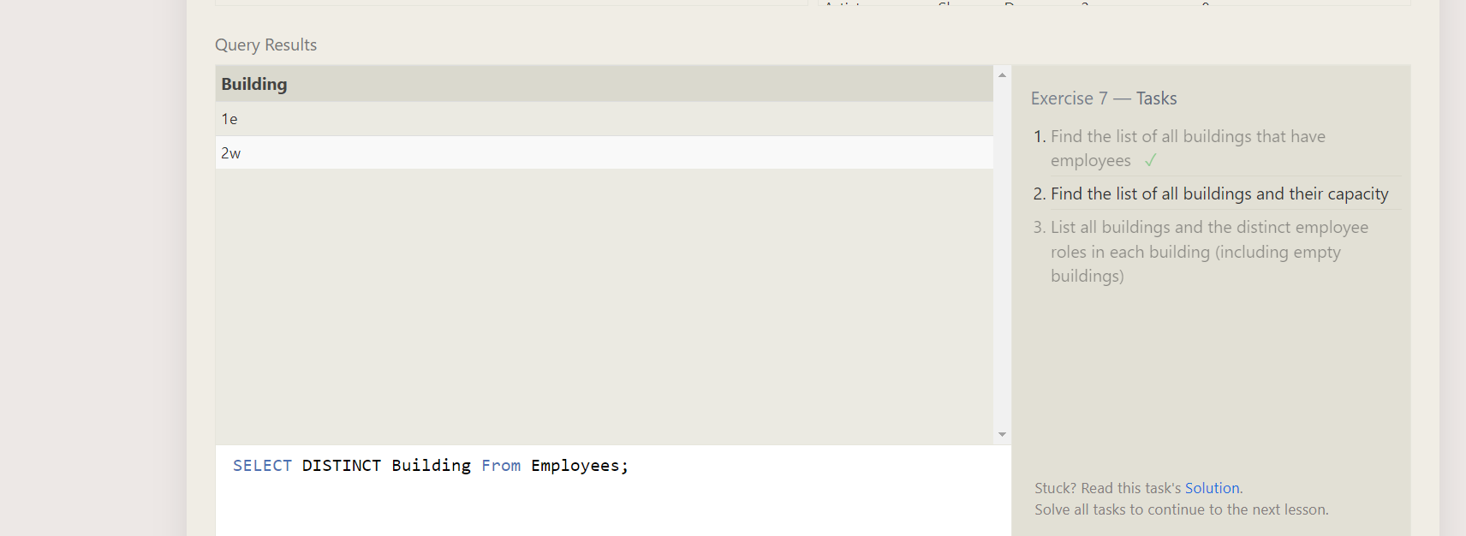

Question-7.2

Find the list of building and their capacity.

Output:-

Question-7.3

List all the building and their distinct role in each building(including empty building).

Output:-

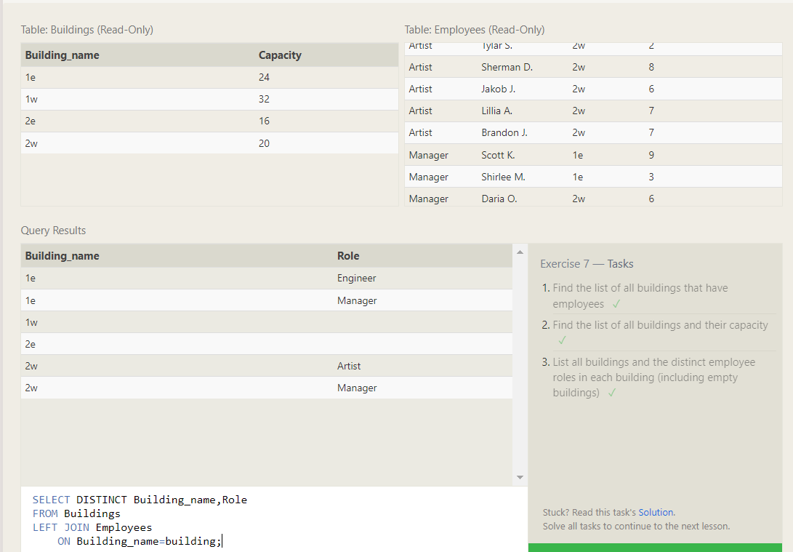

Exercise-8

Question-8.1

Find the name and role of all employees who have not been assign a building.

Output:-

Question-8.2

Find the building who hold no employees.

Output:-

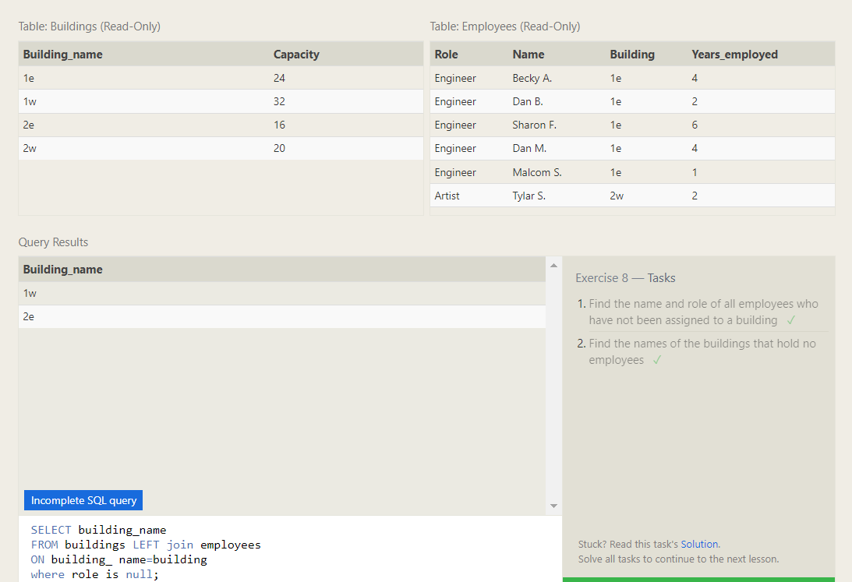

Exercise-9

Question-9.1

List of all movies and their combined sales in millions of dollars.

Output:-

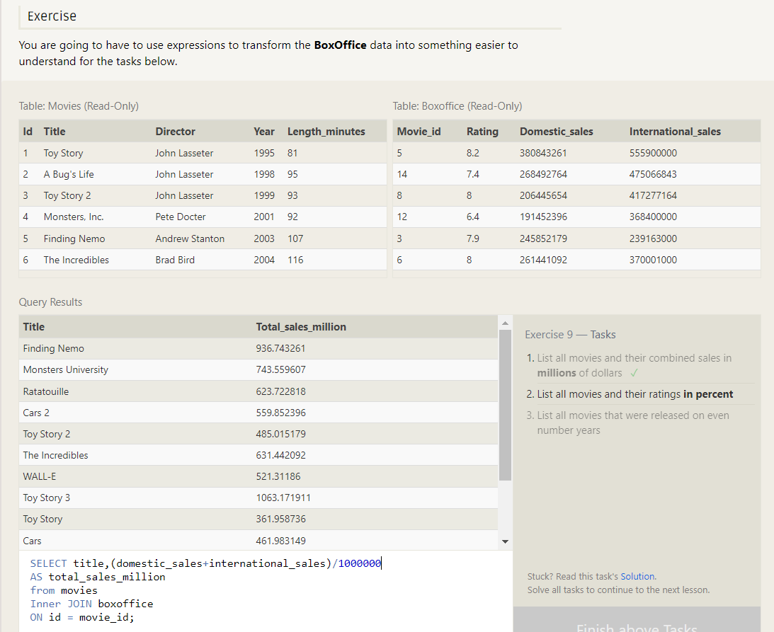

Question-9.2

List of all movies and their rating in percentage.

Output:-

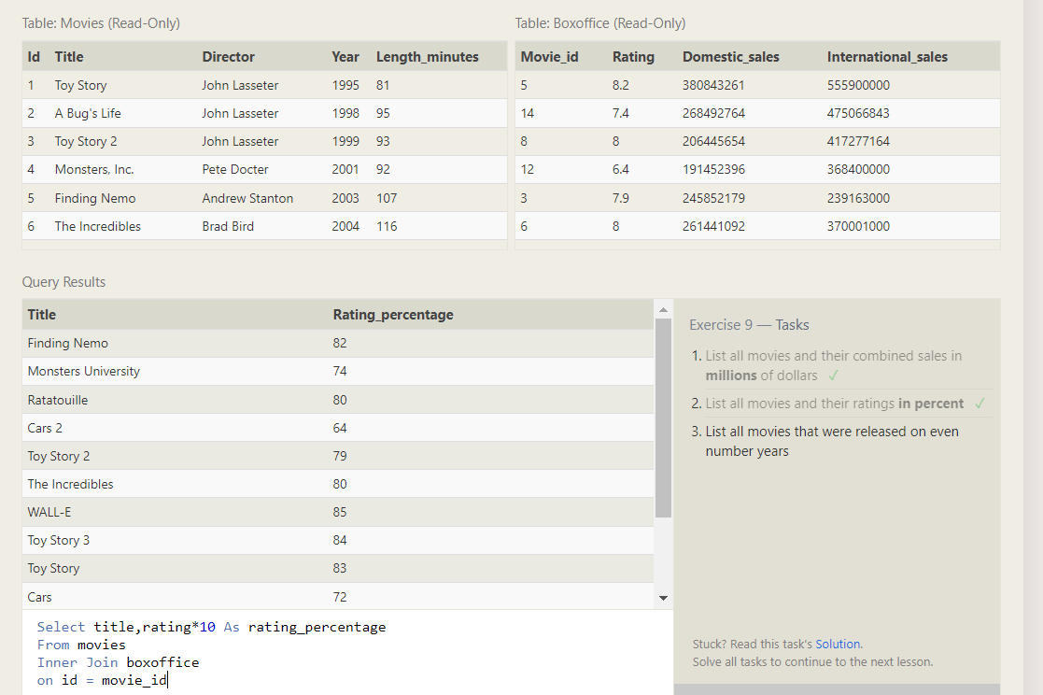

Question-9.3

List all movies that were released even number year.

Output:-

Exercise-10

Question-10.1

Find the longest time that employee has been at the studio.

Output:-

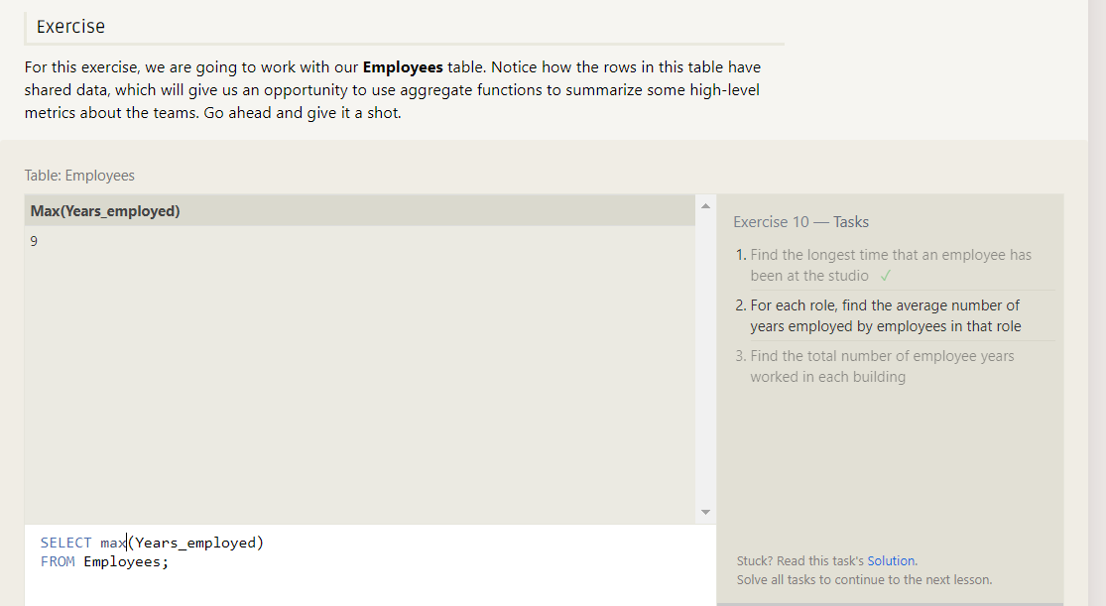

Question-10.2

For each role find the average no.of years employees in that role.

Output:-

Question-10.3

Find the total number of employee years worked in each building.

Output:-

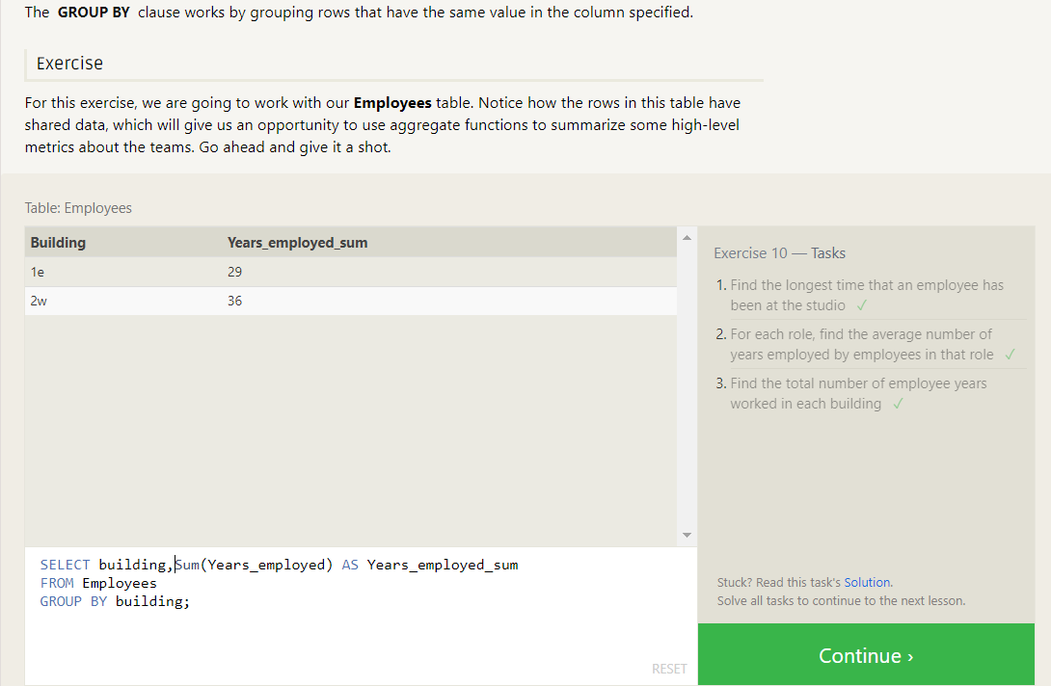

Exercise-11

Find the number of artists in the studio (without a having clause)

Output:-

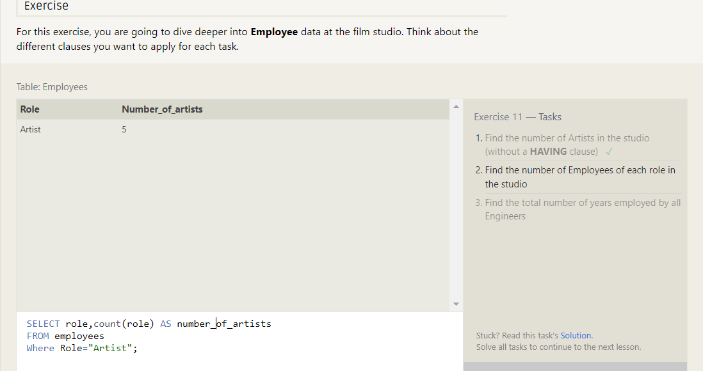

Question-11.2

Find the number of employee from each role.

Output:-

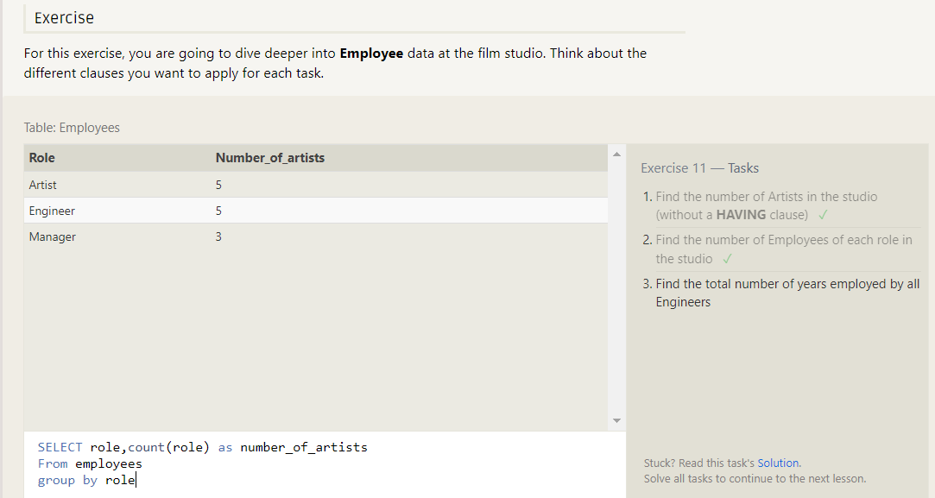

Question-11.3

Find The total number of years employed by all engineers.

Output:-

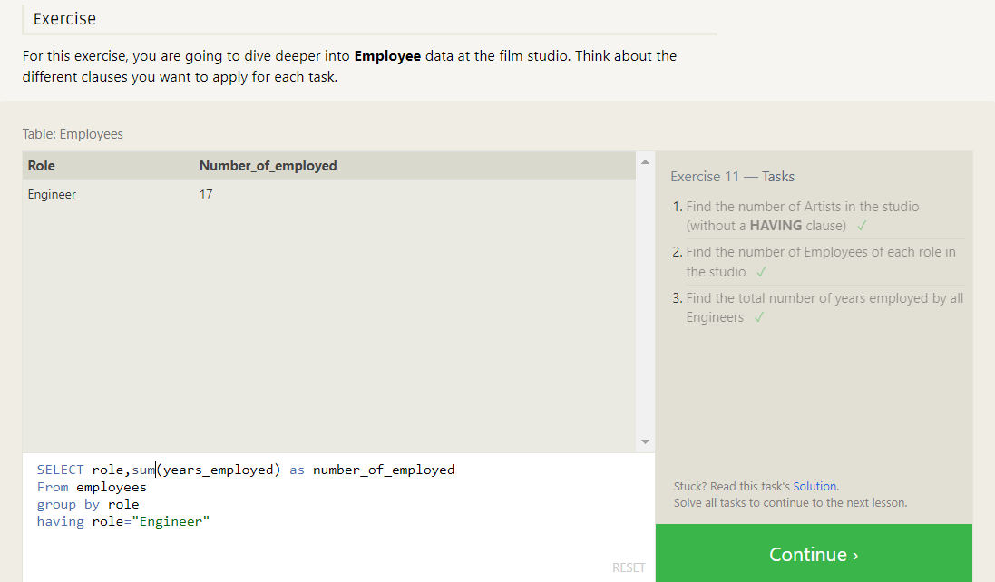

Exercise-12

Question-12.1

Find the number of movies each director has directed.

Output:-

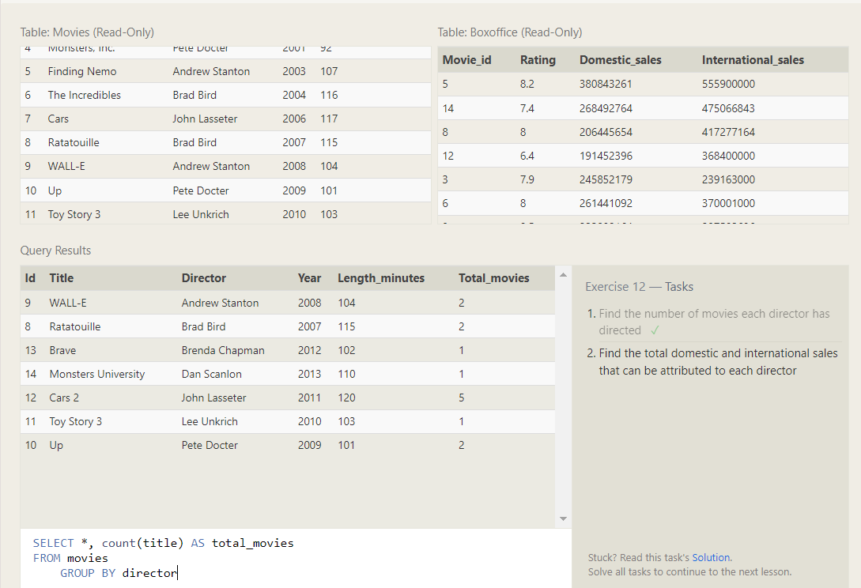

Question-12.2

Find the total domestic and international sales that can be attributed to each director.

Output:-

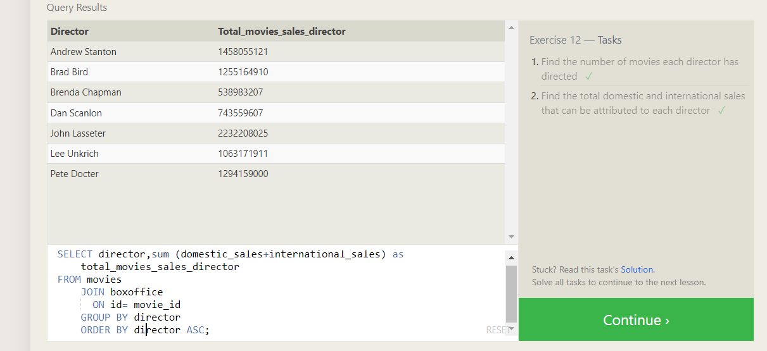

Exercise-13

Question-13.1

Add the studio’s new production.

Output:-

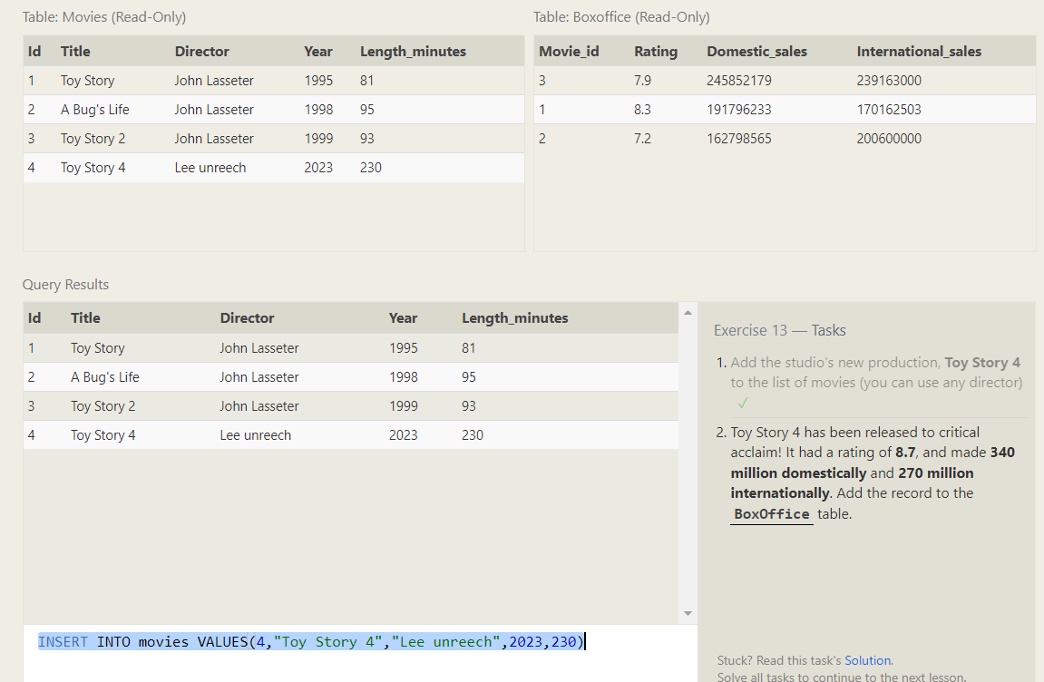

Question-13.2

Toy Story 4 has been released to critical acclaim! It had a rating of **8.7**, and made **340 million domestically** and **270 million internationally**. Add the record to the **BoxOffice** table.

Output:-

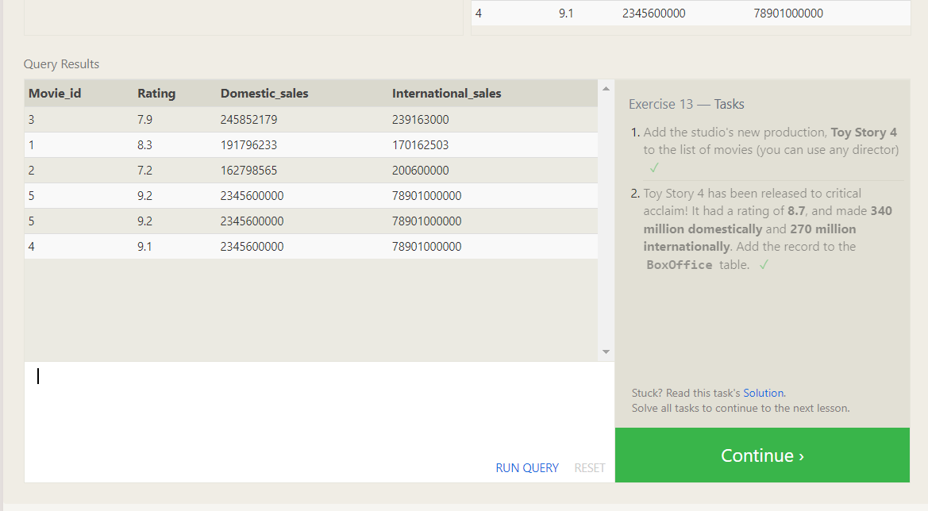

Exercise-14

Question-14.1

Update Row.

Output:-

Question-14.2

Update year.

Output:-

Question-14.3

Just update 3 things.

Output:-

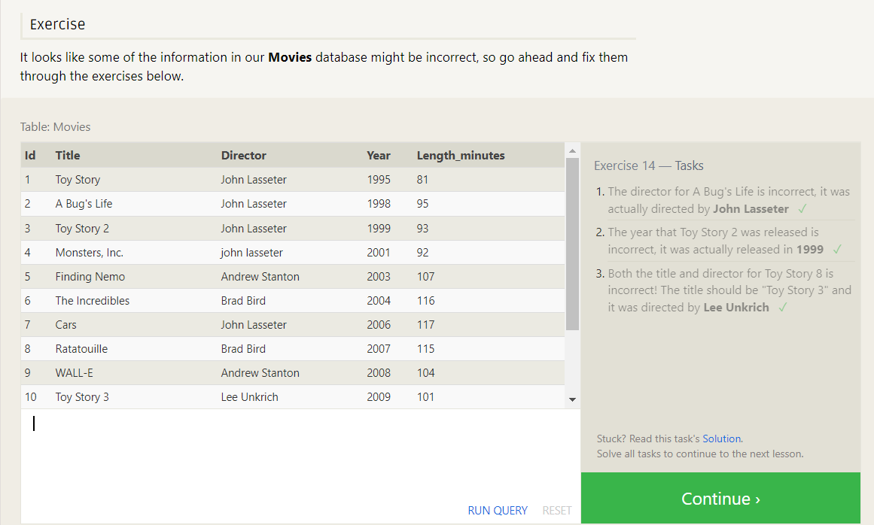

Exercise-15

Question-15.1

Delete Told Row

Output:-

Question-15.2

Delete Andrew Stanton.

Output:-

Exercise-16

Question-16.1

Create a new table named **Database** with the following columns:

– **Name** A string (text) describing the name of the database  
– **Version** A number (floating point) of the latest version of this database  
– **Download_count** An integer count of the number of times this database was downloaded

Output:-

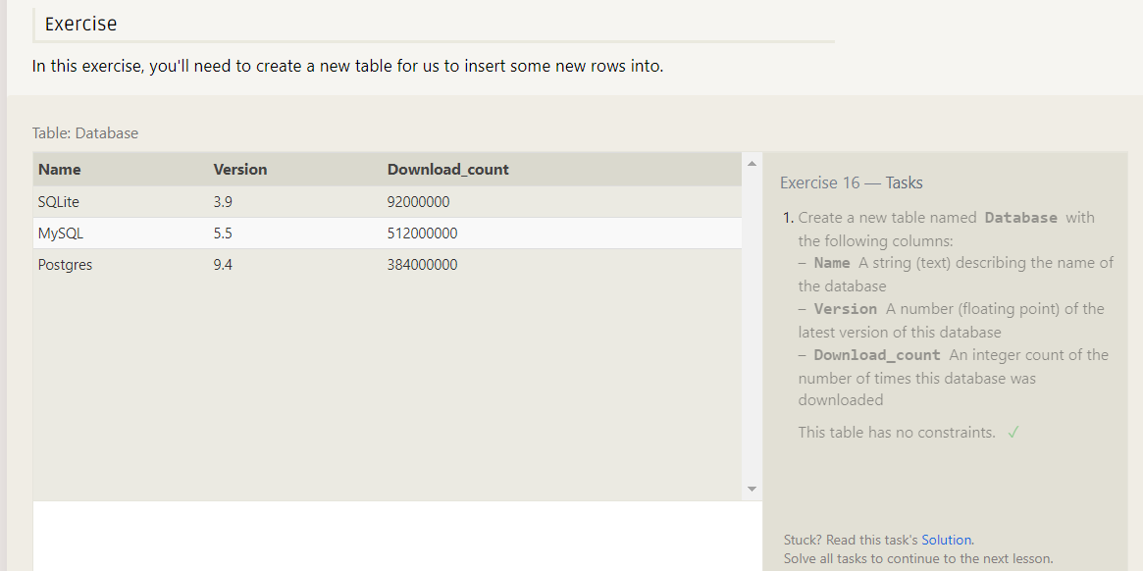

Exercise-17

Question-17.1

Add column named aspect_ratio.

Output:-

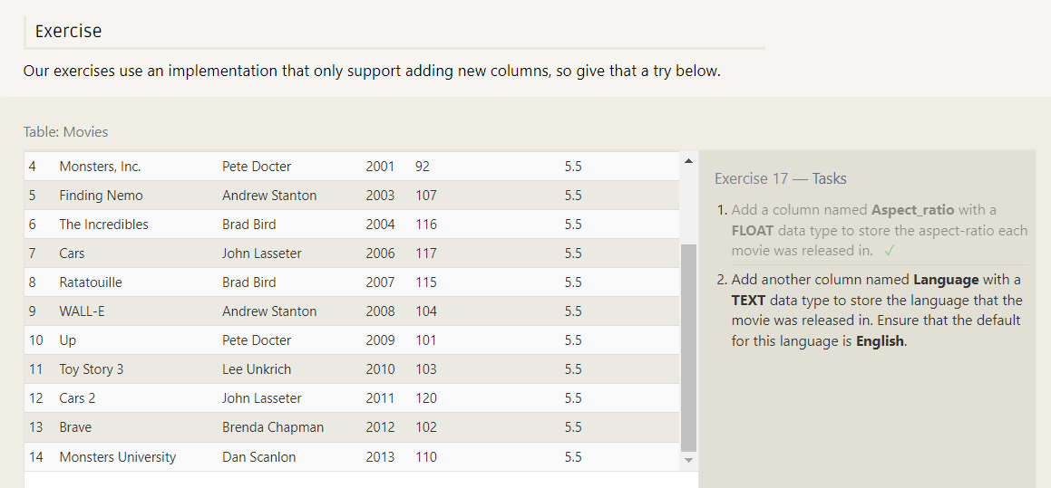

Question-17.2

Add Column to that table.

Output:-

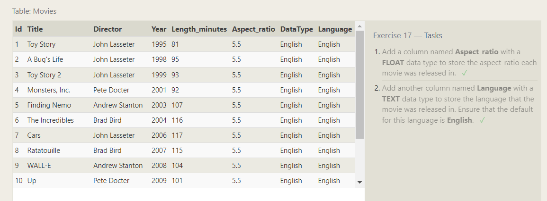

Exercise-18

Question-18.1

Drop Movies Table.

Output:-

Question-18.2

Drop Box office Table

Output:-

